Artificial Neural Network for System Identification

Project-1

Aim: To train a single layer neural network with the input of sinusoidal signals, evaluate the results.

Parameters:

* Number of inputs: 5
* The frequency of sinusoidal sampling: 100
* Adaptive Algorithm: Backpropagation
* Non-linear Activation Function: Sigmoid
* Number of Training Size: 2500
* Learning Rate: 10\*-3
* Cost Function: Least Squares

Data:

An array of consecutive numbers incremented with the defined sampling rate is defined. After that array is used as an input for sinusoidal function. For each training sequence first five of values of the array is chosen as input and the next one namely sixth data is chosen as expected value. Then second training starts with second value of the array and expected value for this case chosen as seventh value of the array.

Results:

A function close to sinusoidal is estimated at the end of the epochs however maximum and minimum values of the estimated sinusoidal-like function is not -1 and 1 rather its 2-0. Although this value of estimation can change depending on different parameters it is not straight forward to say why it did not give a closer result.

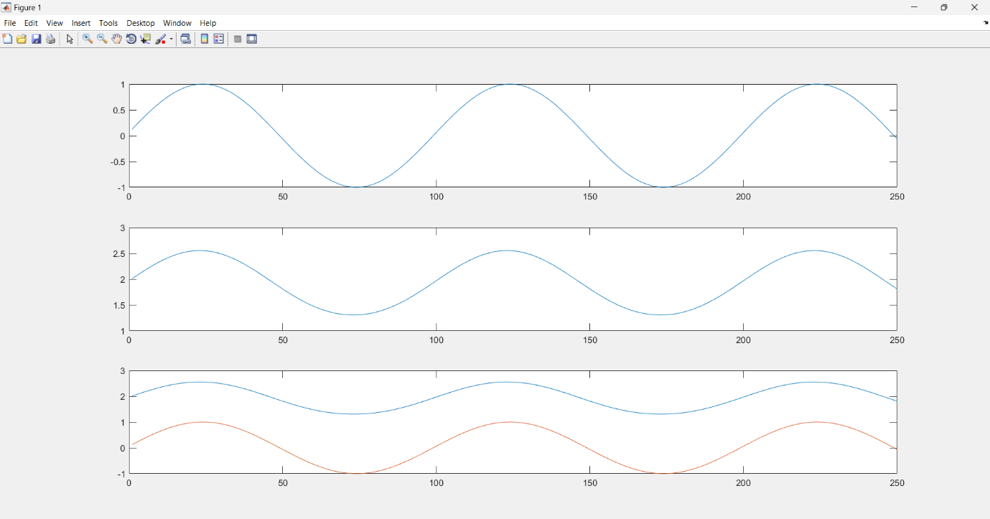

Figure : 1- Input 2- Estimated 3- Input and Estimated

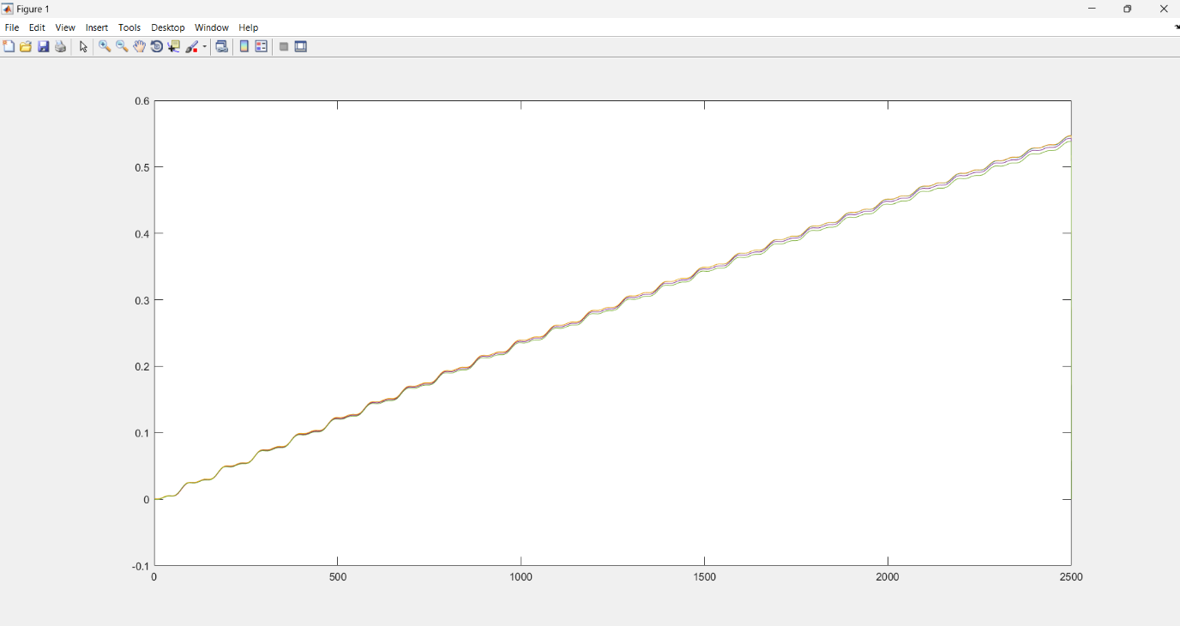

Figure : Weigths Change Over Time

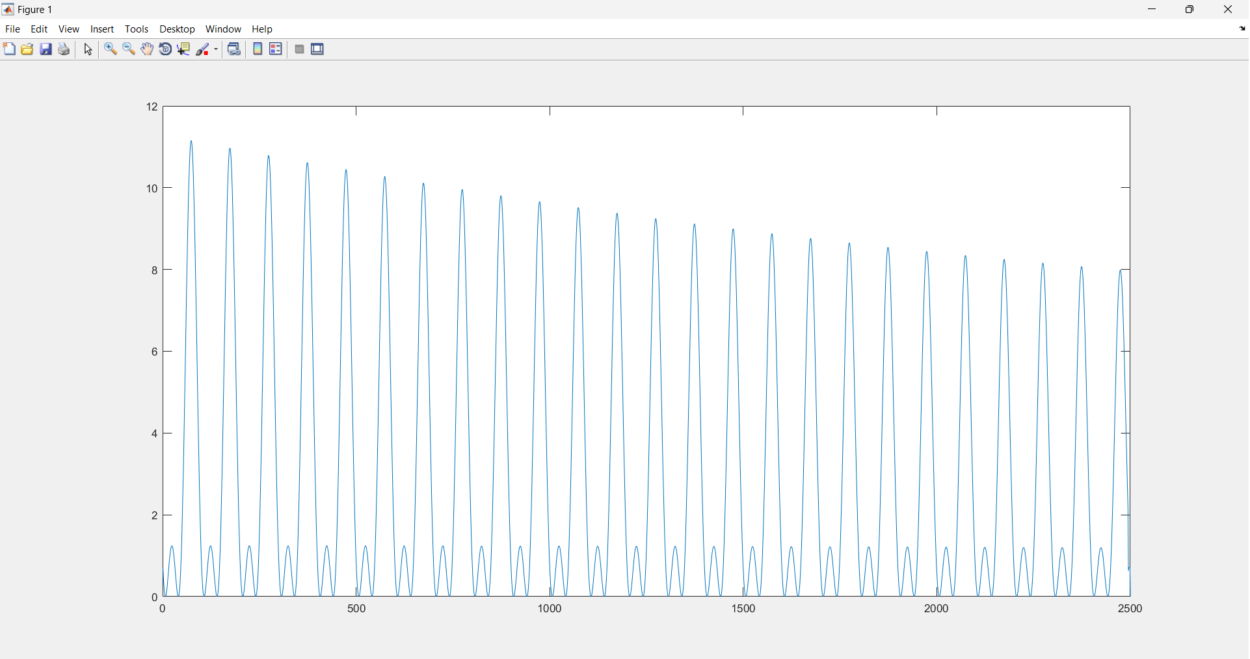

Figure : Loss over time

Code: